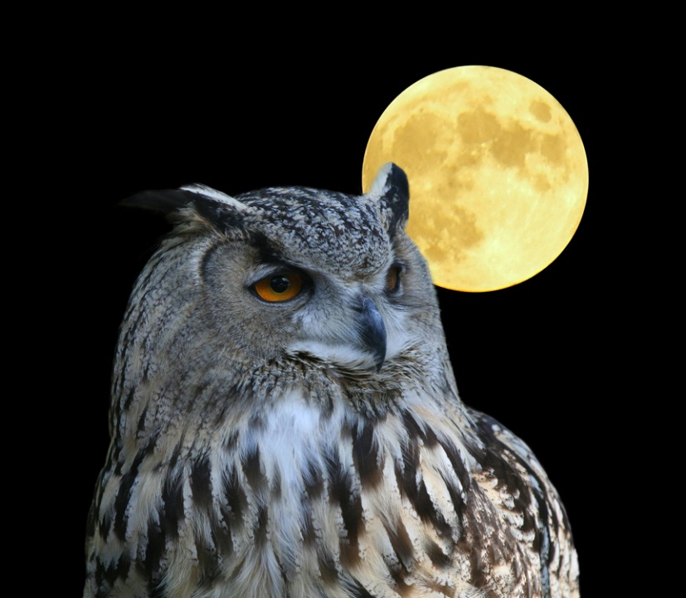
NIGHT OWL 5K RUN/WALK
3rd Annual

September 12th, 2015
Preregistered participants will receive a t-shirt and glow bracelet. Personal head lamps recommended.
Preregistration - $20
After Sept. 6th registration - $25
Check in and registration: 7PM
Race: 8 PM
To preregister: call (402)857-3373, visit http://shopoutdoornebraska.ne.gov/Events/ , or go to the Niobrara State Park office.

